Final Incident Report
Incident ID: 833
Incident Name: Endpoint - File Downloaded via wget
Severity: Medium
Category: Command and Control (C2)
Environment: MTS-Honeypot (Decoy System)
Date: December 1, 2025, 20:01 UTC

Executive Summary
The MTS-Honeypot-an intentionally exposed decoy system, recorded an automated attack originating from IP 1.117.17.128 (China). The attacker executed a chained shell command to download, modify, and execute a malicious Linux binary hosted on 47.254.126.99, a known low-reputation server flagged by multiple vendors. The binary successfully executed and dropped a secondary credential file (/tmp/.opass). All malicious actions occurred within the isolated honeypot, with no impact to production systems.

Findings
Telemetry from the honeypot captured the attacker performing the following actions:
- Downloaded a Linux binary from: http://47.254.126.99:60100/linux
- Saved the payload to /tmp/6j2e75fl4E
- Changed file permissions using chmod +x
- Executed the binary along with a long, encoded parameter
- Dropped an additional file:
/tmp/.opass containing the password Aa@123456
- Re-executed the binary with the same encoded payload, suggesting botnet enrollment or C2 initialization attempts
The presence of execution logs confirms the binary did run successfully.

Investigation Summary
On December 1, 2025, Microsoft Defender alerted on suspicious command execution associated with custom logs uploaded to the Defender portal.
Analysis of logs from MTS_Honeypot_CL shows the attacker delivered a multi-stage command designed for maximum resilience. The command attempted three download paths:
- curl
- wget
- Raw socket retrieval via /dev/tcp
After obtaining the binary, the attacker attempted to execute it twice, passed encoded parameters resembling botnet registration tokens, and wrote what appears to be a scripted password to /tmp/.opass.
This behaviour is consistent with:
- Automated botnet propagation
- Opportunistic compromise of exposed SSH endpoints
- C2 beaconing and execution of malicious payloads
No further activity was observed after the initial execution chain.

Incident Breakdown (Who, What, When, Where, Why, How)
Who
Attacker IP: 1.117.17.128
- Geolocation: China
- Low reputation, associated with automated scanning and exploitation
C2/Hosting Server: 47.254.126.99
- 2/95 security vendors flagged as malicious
- Associated with Alibaba US Technology Co., Ltd. (AS45102)
- Behaviour consistent with malware delivery infrastructure

What
The attacker:
- Downloaded and executed a malicious Linux binary
- Dropped a credential file (/tmp/.opass) with password Aa@123456
- Executed an encoded command payload twice
- Leveraged multiple fallback download methods to ensure payload delivery

When
- 18:58:35 UTC – Malicious command executed (TimeGenerated)
- 20:01 UTC – Microsoft Defender flagged the incident

Where
- Impacted System: MTS-Honeypot
- MTS_Honeypot_CL custom logs uploaded to the Defender portal

Why
- Part of a mass internet-wide botnet propagation campaign
- Automated exploitation targeting exposed SSH services
- Likely intended to enroll compromised devices into a botnet for further C2 activity

How
The attacker utilized a chained shell one-liner that performed the following:
- Remotely connected to the SSH honeypot
- Attempted to download malware using:
  - curl
  - wget
  - /dev/tcp fallback
- Saved the payload to /tmp/6j2e75fl4E
- Made it executable with chmod +x
- Executed the binary with a long-encoded argument
- Wrote /tmp/.opass containing Aa@123456
- Re-ran the binary with the same encoded payload
This sequence aligns with behaviours seen in Mirai-like and general Linux botnet families.

MITRE Assessment Summary
The attacker exploited an exposed SSH service to execute obfuscated commands, download a malicious payload, and run it on the honeypot.
Their actions align with techniques such as Remote Service Exploitation, Command Execution, Obfuscated Command Use, and C2 communication via HTTP.

Recommendations
- Block malicious IPs at the perimeter confirmed not to be part of any approved internal process, testing or red-team activities i.e.,
  - 1.117.17.128 (Attacker)
  - 47.254.126.99 (C2 / Malware host)
- Continue monitoring the honeypot for emerging botnet activity, maintaining strict isolation from production networks.
- Onboard MTS-Honeypot to Microsoft Defender for Endpoint to obtain:
  - Full process and network telemetry
  - Real-time attack chain mapping
  - Automated detection and response
  - Enhanced forensic visibility beyond current custom log uploads
- Implement automated enrichment and alerting for repeated attempts involving the same infrastructure, as attackers often reuse C2 hosts across campaigns.

Additional Note
The log ingested into Microsoft Defender was in raw text format, requiring custom parsing using Regular Expressions (regex) to extract critical fields such as SrcIP, Command, and MalwarePath. To accelerate and validate the regex creation process, ChatGPT was utilized.

Screenshots
Figure 1: Showing Incident overview page
Figure 2: Shows the attacker executed remote command downloads using multiple redundancy methods
Figure 3: Showing successful extraction and enrichment of honeypot attack telemetry
Figure 4 and 5: Showing Reputation Check for Attacker IP and Malware/C2 host respectively

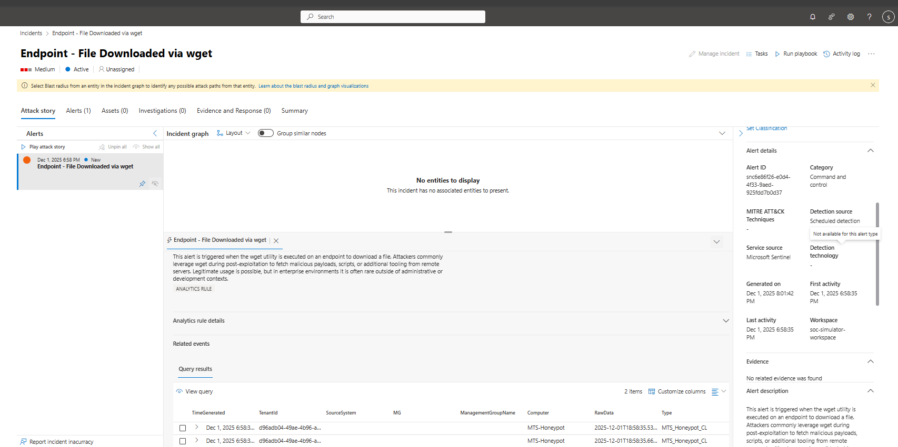
Figure 1

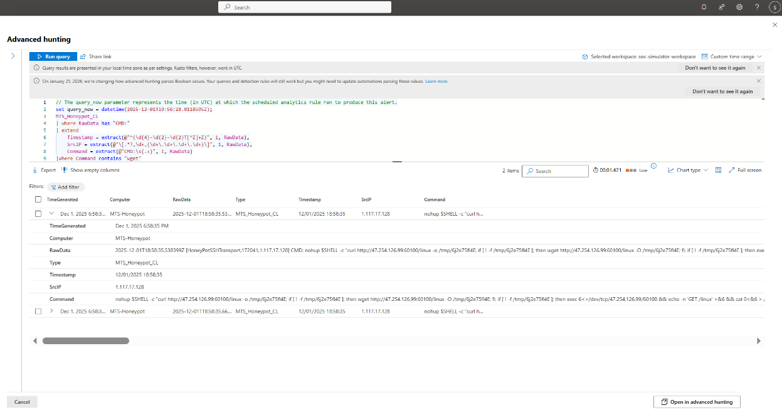
Figure 2
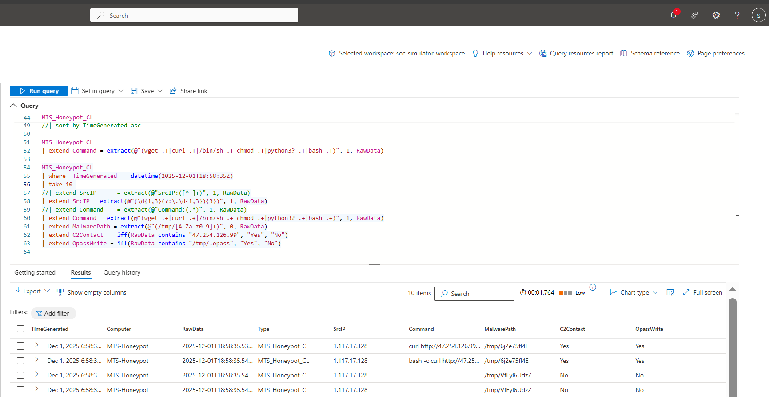
Figure 3
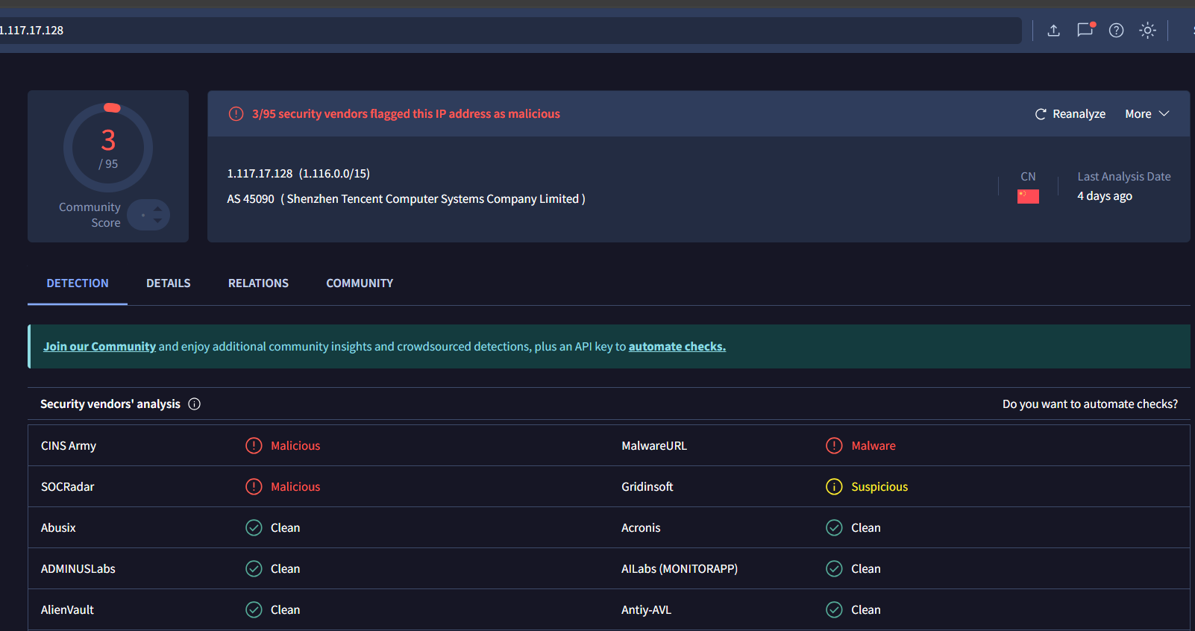
Figure 4

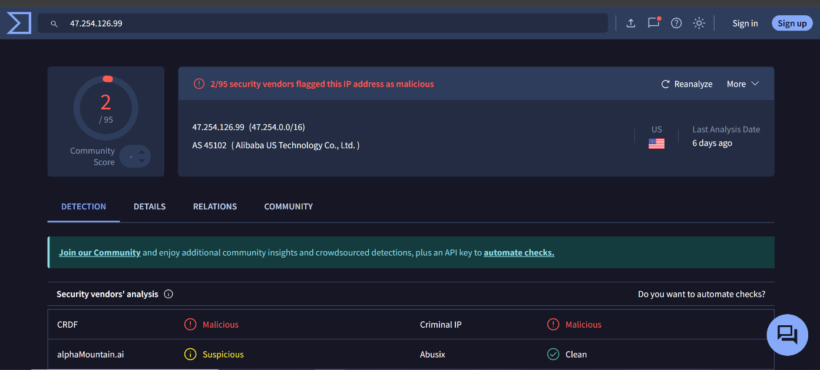
Figure 5

